Week -0

QUESTION NO : 1
Write an algorithm and draw a flowchart to calculate the area and perimeter of a square.

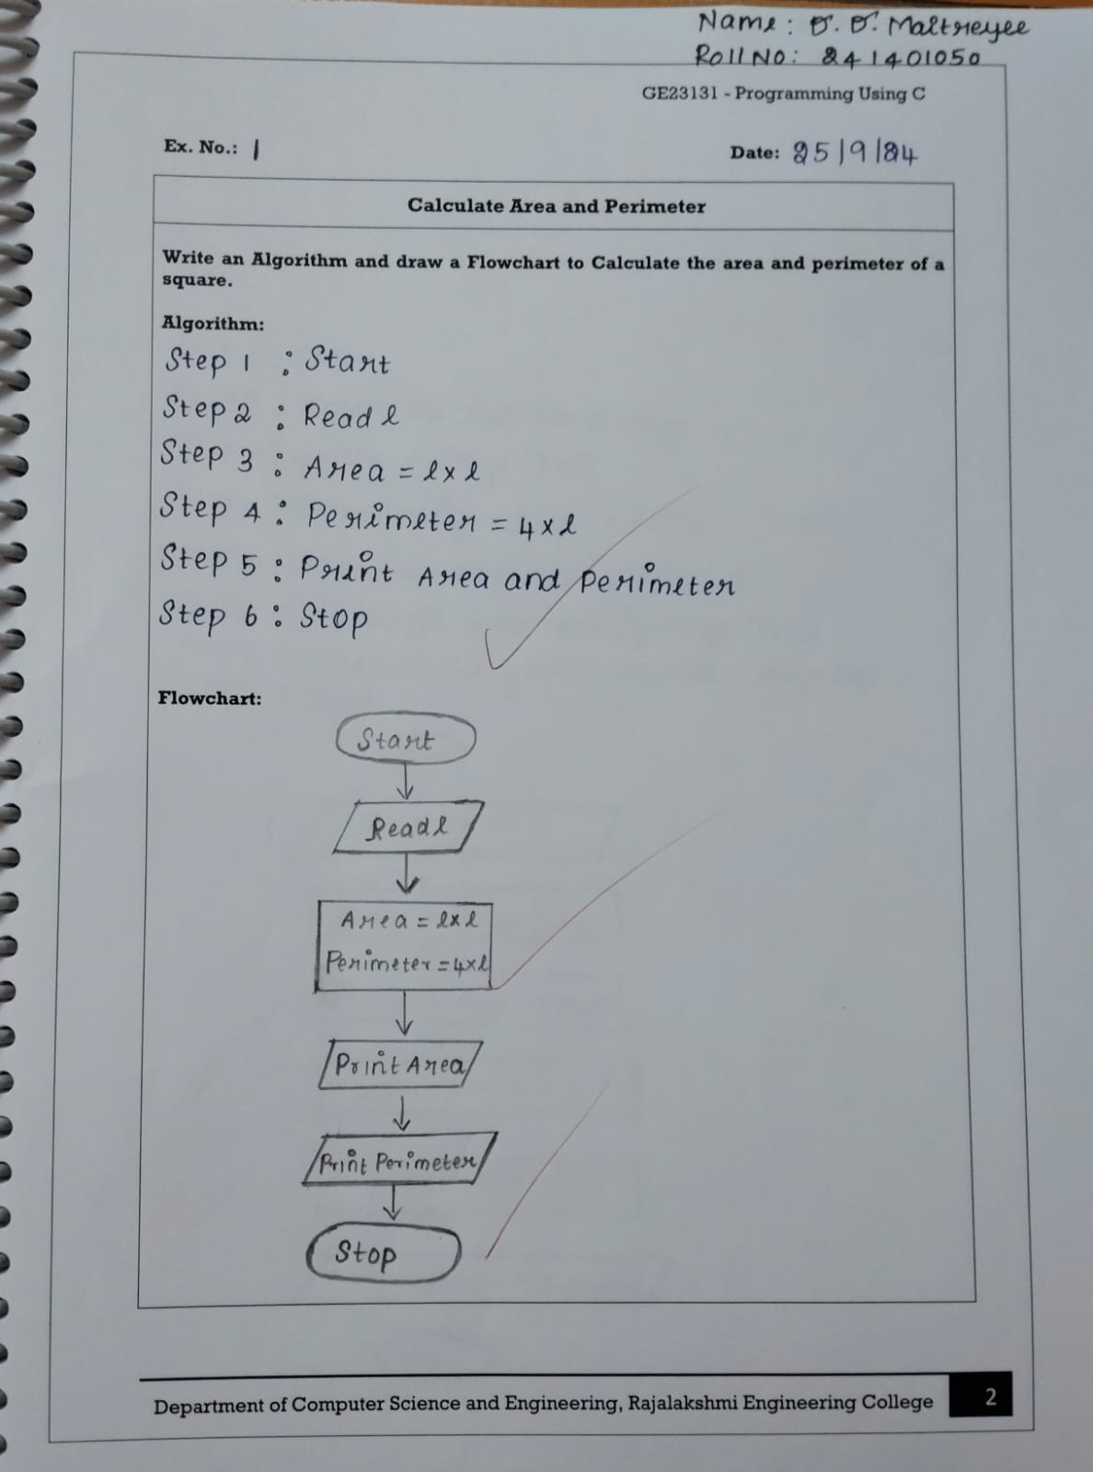

QUESTION NO 2 :
Write an algorithm and draw a flowchart to convert the given days into years and months.
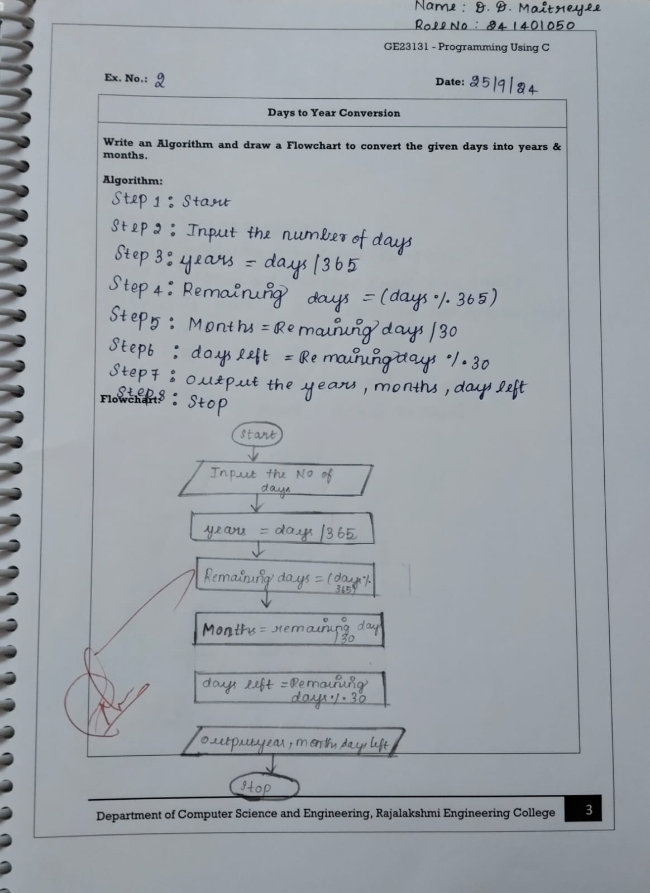
QUESTION NO 3 :
WRITE AN ALGORITHM AND DRAW A FLOWCHART TO CHECK WHETHER THE GIVEN NUMBER IS PRIME OR NOT
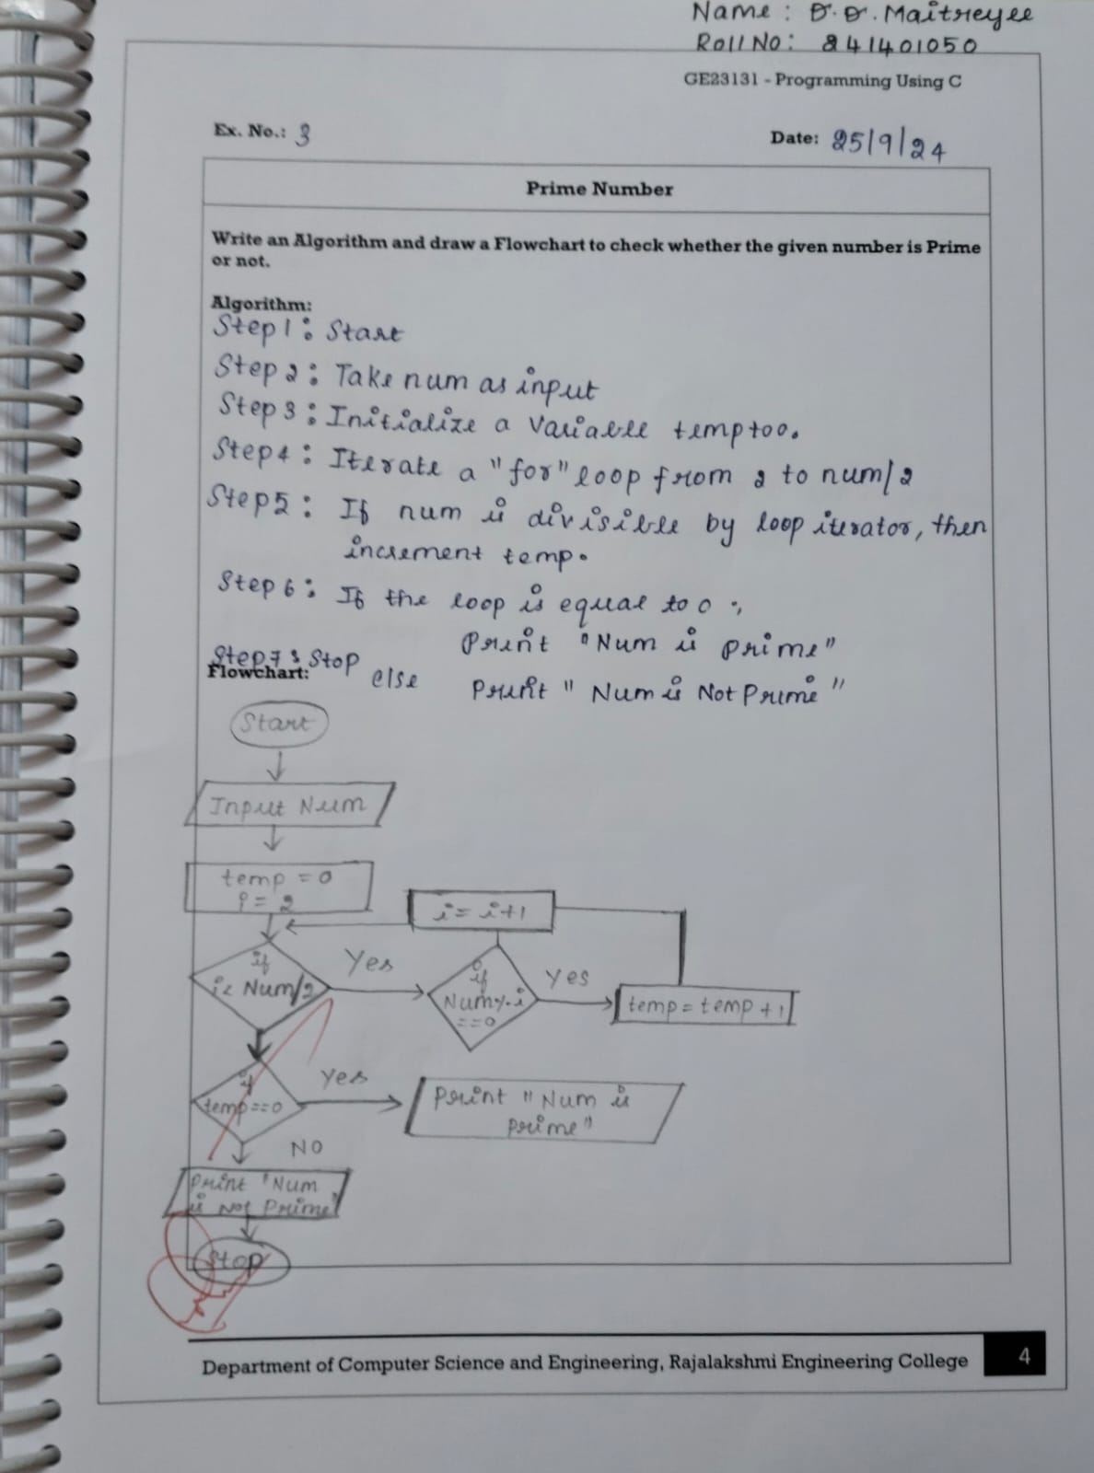
QUESTION NO 4:
WRITE AN ALGORITHM AND DRAW A FLOWCHART TO CHECK WHETHER THE GIVEN YEAR IS LEAP YEAR OR NOT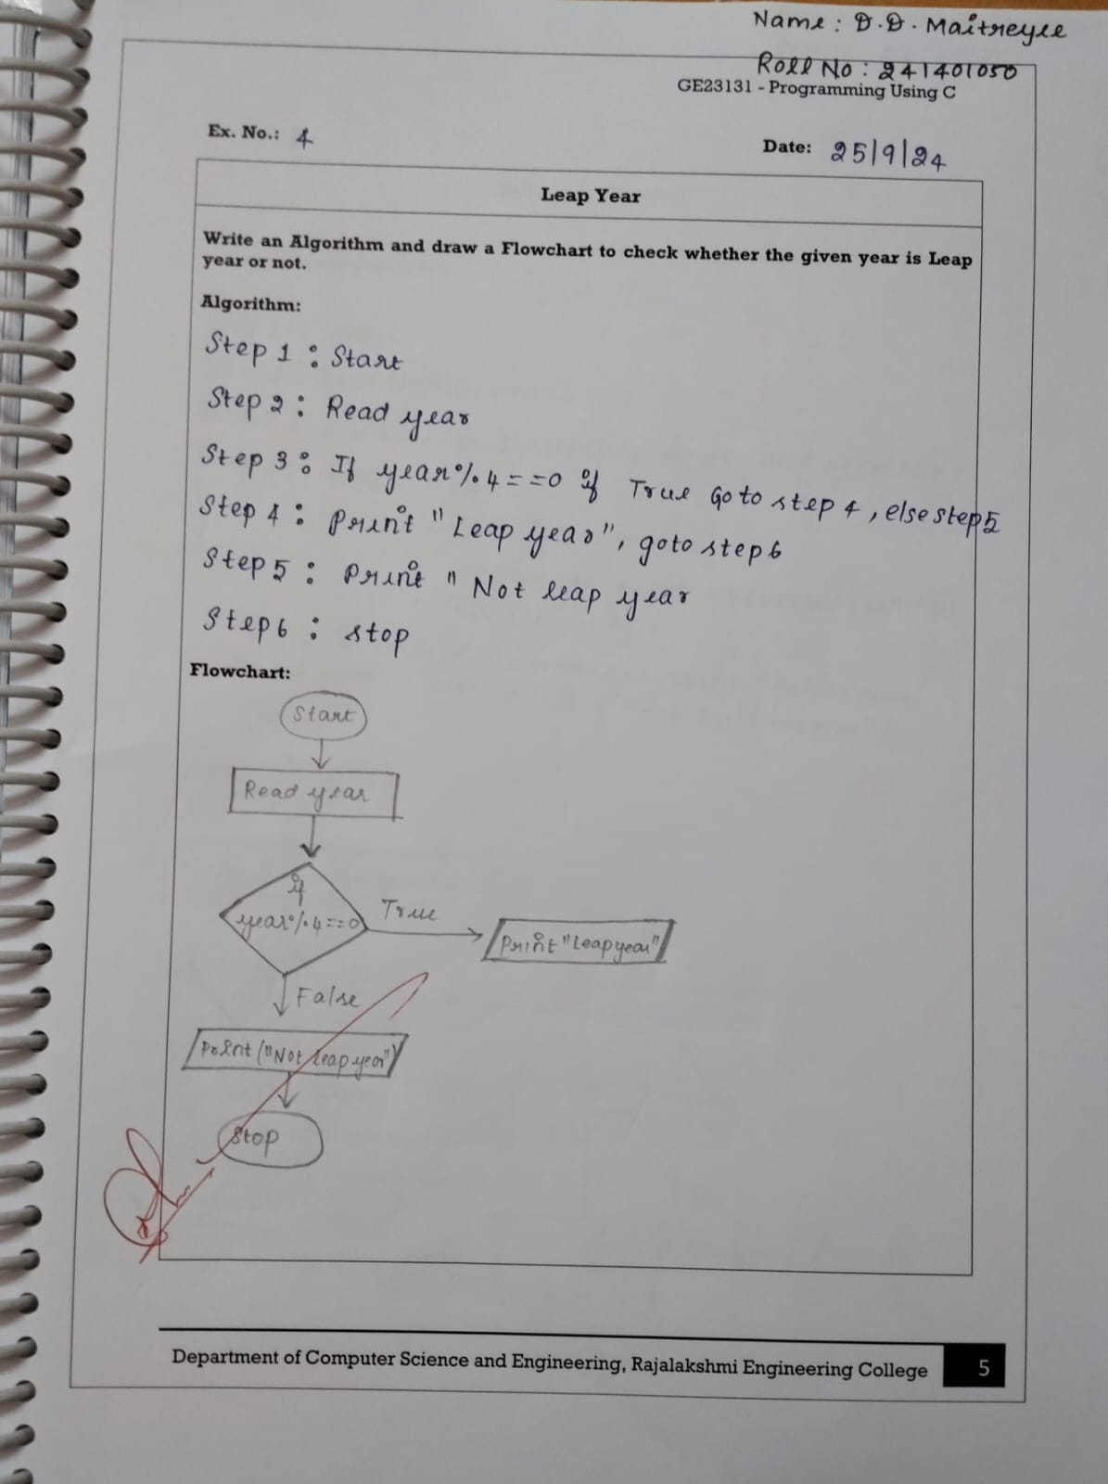

QUESTION NO 5:
WRITE AN ALGORITHM AND DRAW A FLOWCHART TO CHECK WHETEHER THE GIVEN NUMBER IS PALINDROME OR NOT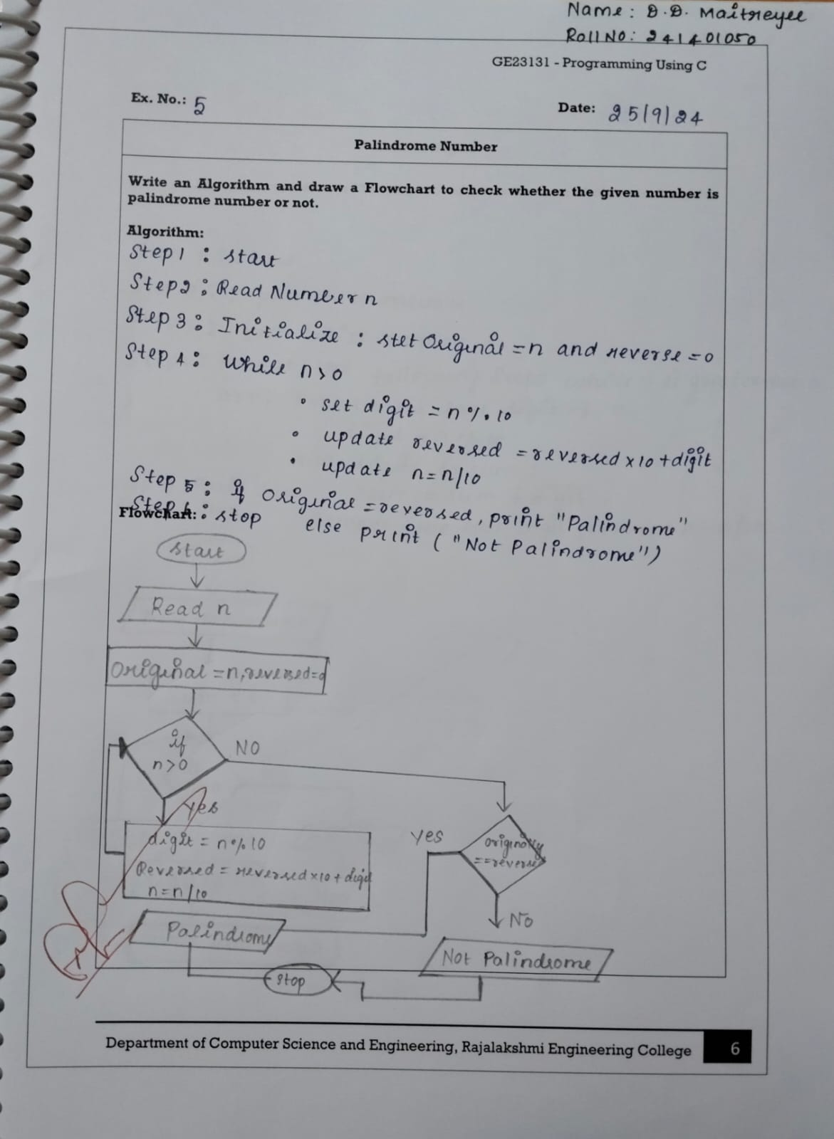
QUESTION NO 6 :
WRITE AN ALGORITHM AND DRAW A FLOWCHART TO CALCULATE THE SUM OF DIGITS IN THE GIVEN NUMBER